1. **Explained Variance by Each Component**:
   * The PCA revealed the proportion of variance explained by each principal component. The first few components accounted for a significant portion of the variance in the dataset, with the first component being the most influential.
2. **Cumulative Variance**:
   * The cumulative variance indicated how much total variance is explained as more components are added. By selecting components that cumulatively explain about 80% of the variance, a balance was achieved between reducing dimensionality and retaining meaningful information in the data.
3. **Number of Components for 80% Variance**:
   * The analysis identified the optimal number of components to retain for capturing approximately 80% of the total variance in the data. This provides a reduced yet comprehensive representation of the dataset.
4. **Interpretation of Principal Components**:
   * Each principal component represents a linear combination of the original variables. The components captured various aspects of the data:
     + **PC1** seemed to capture elements related to various forms of perceived discrimination in the workplace.
     + **PC2** showed a contrast between age and education level, possibly reflecting different socio-economic or generational experiences.
     + Subsequent components represented more nuanced aspects of the data, each orthogonal to the others, highlighting unique patterns or relationships.

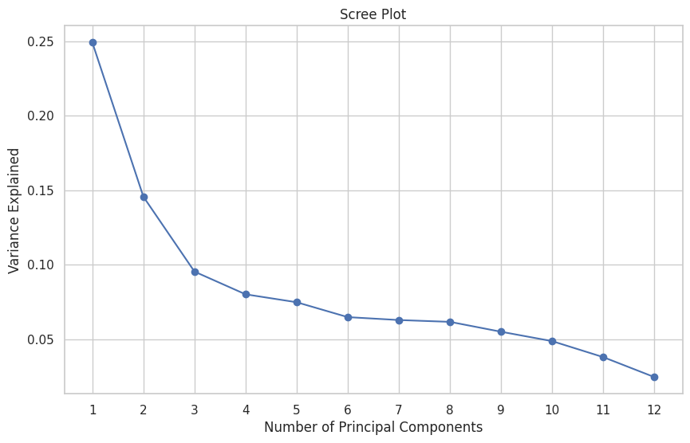

[1. Explained Variance]

The scree plot has been created to help in deciding the number of principal components (PCs) required to visualize the data effectively.

In the scree plot, each point represents the amount of variance that is captured by each principal component. Typically, you'd look for a point at which the plot starts to level off, known as the 'elbow'. This point indicates that adding more components doesn't explain much more of the variance. The number of components before the elbow is usually a good choice for reducing dimensionality while still capturing most of the variance in your data.

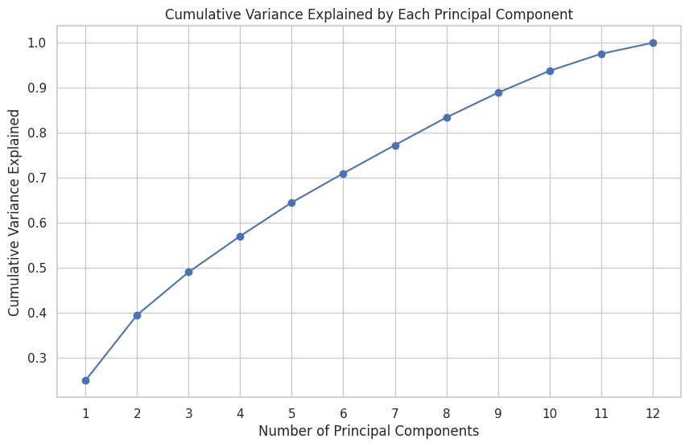

[2. Cumulative Variance Explained by PCs]

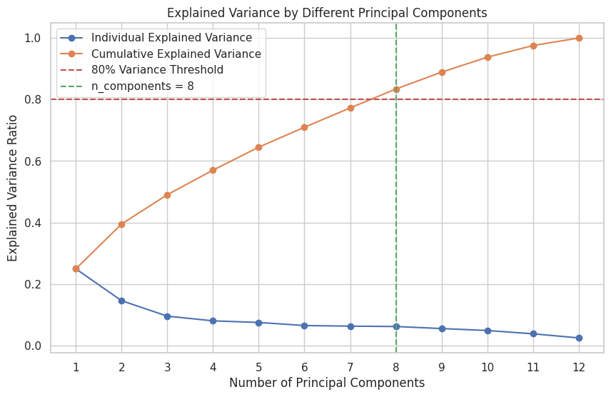

[3. Number of Components for 80% Variance]

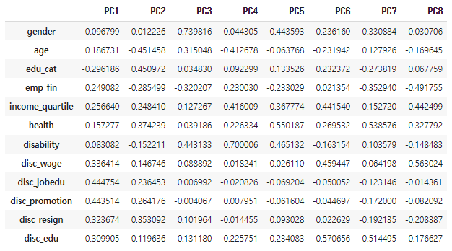

[4. Interpretation of Principal Components]

1. **PC1 (First Principal Component)**:
   * This component has high positive coefficients for **disc_wage**, **disc_jobedu**, **disc_promotion**, **disc_resign**, and **disc_edu**, suggesting it captures elements related to various forms of perceived discrimination in the workplace. It might represent an overarching factor related to experiences or perceptions of discrimination.
2. **PC2 (Second Principal Component)**:
   * This component shows a strong negative association with **age** and a strong positive association with **edu_cat**, indicating it captures a contrast between age and education level. This might reflect different socio-economic or generational experiences.
3. **Subsequent PCs**:
   * The interpretation of further components requires a closer look at their coefficients. Generally, a high positive or negative coefficient indicates that the component is heavily influenced by that variable.
   * For instance, if a component has high coefficients for variables like **gender** or **health**, it might represent gender-based differences or health-related aspects, respectively.
4. **Overall Interpretation**:
   * The first few PCs usually capture the most significant patterns in the data, with later PCs representing more nuanced or complex relationships.
   * It's important to remember that PCs are orthogonal to each other, meaning each represents a unique aspect of the data that is not captured by the others.